Little and Junior
Miss Lumbee Pageant
2016-2017
Tuesday, June 28, 2016

Contestant Application

Sponsored by Lumbee Regional Development Association, Inc. (LRDA)

Application Deadline:
March 31st, 2016
For more Information, please contact:
Crystal J. Strong or Sharlene Oxendine at (910) 521-8602

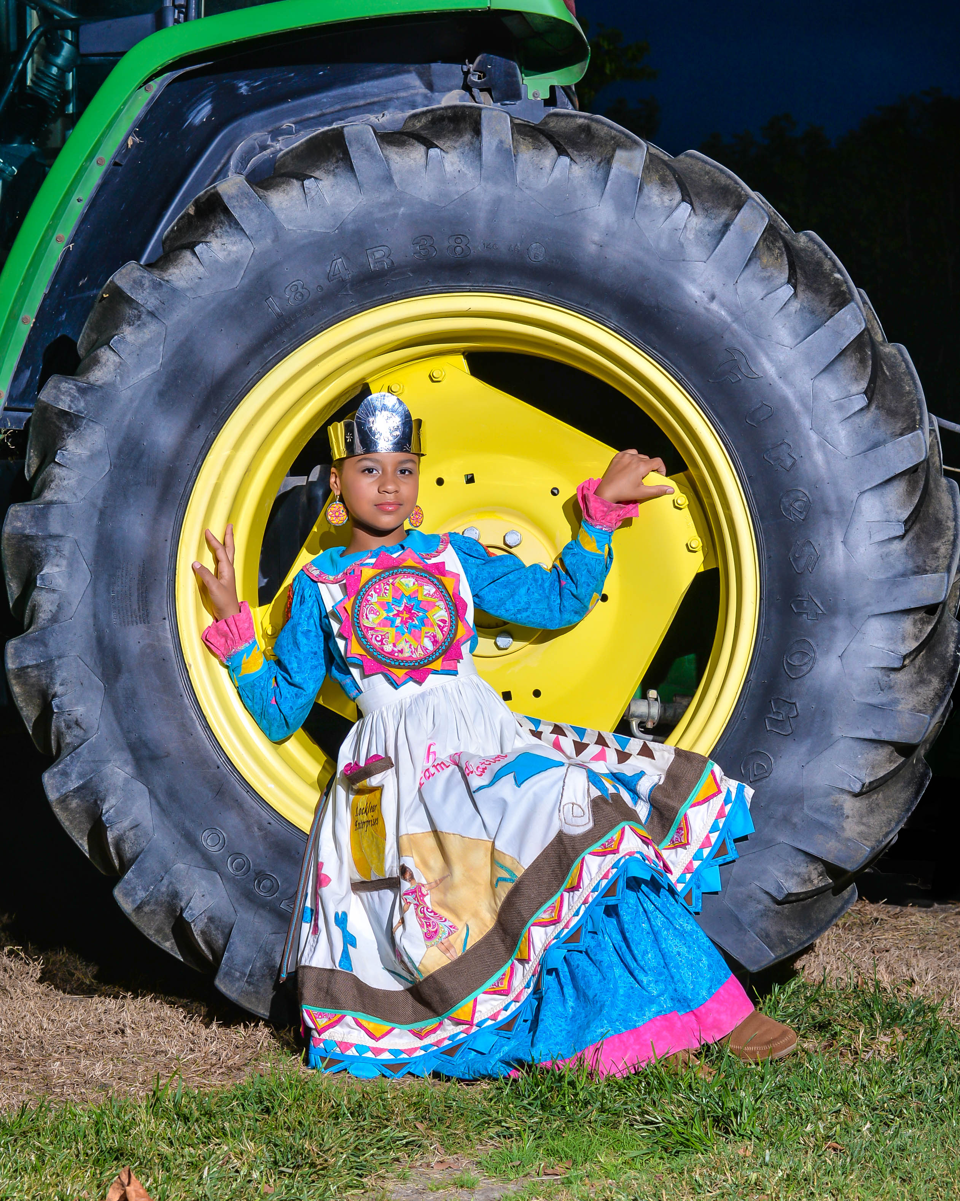

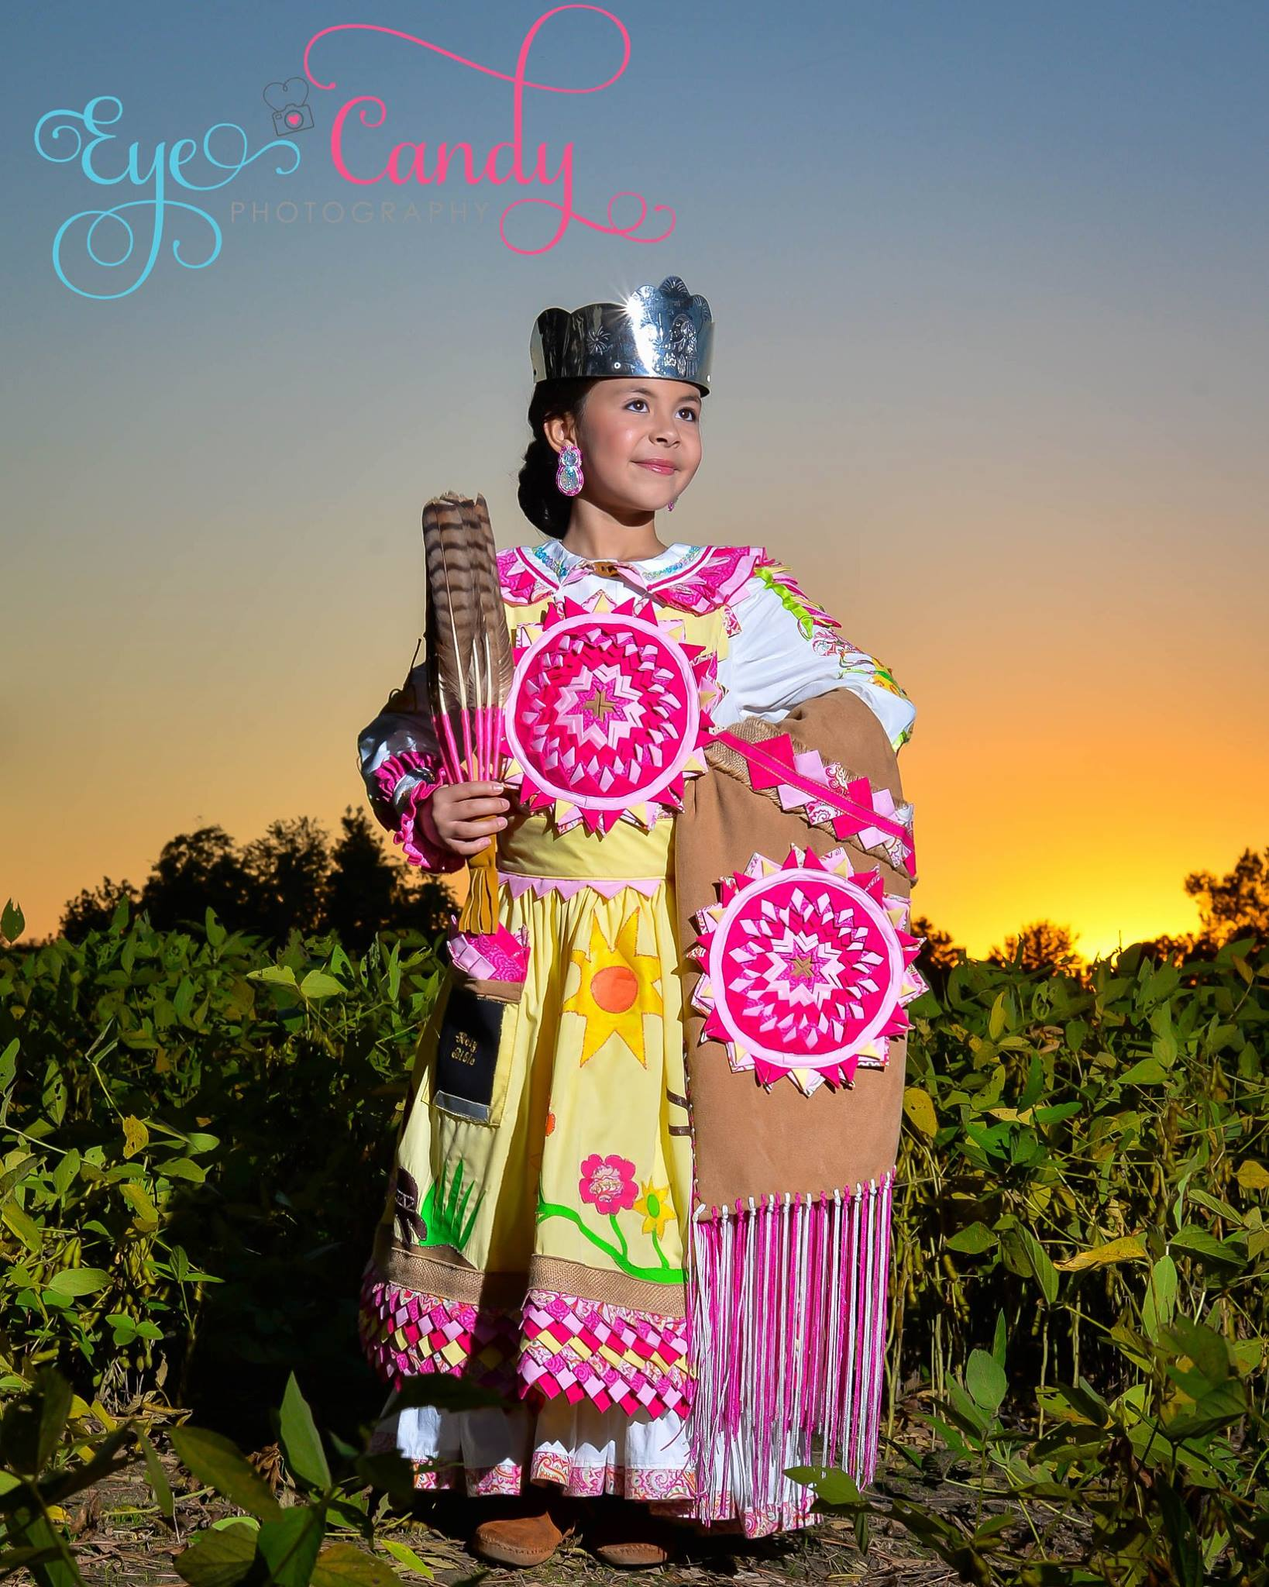

REQUIRED CATEGORIES OF COMPETITION

Little Miss Lumbee Competition (5-9 yrs. old)
On Stage Question – 20%
Regalia – 30 %
Talent (2 ½ minute limit) – 30%
Jr. Miss Lumbee Competition (10-13 yrs. old)
On Stage Question – 20%
Regalia – 30%
Talent (2 ½ minute limit) – 30%

Evening Wear (short and age appropriate) – 20% Evening Wear (long and age appropriate) – 20%

To complete the application process, you are REQUIRED to submit the following list of items:

Official Entry Application (TYPED ONLY) Deadline to submit applications is March 31, 2016.

- Submitting an application does not guarantee that an applicant will be accepted as a contestant. If accepted, applicants will be notified with an acceptance letter as soon as possible.

Registration Fee $150.00

Please make all money orders payable to: LRDA Homecoming (Little & Jr Miss Pageant)

Regalia, Talent and Beauty Information (to be used the night of the pageant) and CD (one song only on CD please) must be turned in by June 3, 2016.

- Please have two-talent CD’s: one for rehearsal and one for the night of the performance!

Contestant/Parent Signature on Official Application

Certification of Lumbee Tribal Enrollment

Copy of Birth Certificate

Essay: “Why I want to be Little/Jr. Miss Lumbee” (No color or cover page) Essay’s must be TYPED ONLY and please include your name. Little Miss Contestant Essay should be 100 words and Jr. Miss Contestant Essay should be 200 words.

Please submit completed applications to:
Little/Jr. Miss Lumbee Pageant (Attention: Crystal J. Strong, Pageant Director)
Lumbee Regional Development Association, Inc. P.O. Box 68
Pembroke, NC 28372

Little or Junior Miss Lumbee
Contestant Application
2016-2017
First Name |  | Middle Name |  |  | Last Name
Address |  |  | Mother’s Name |  |  | Father’s Name
City |  | State  North Carolina |  | Zip Code |  | Little Junior
Home Phone | Cell Phone | Date of Birth  Month Day Year |  |  |  |  | Age
TALENT INFORMATION

Type of Talent Singer Dancer Other(please explain): _ MUST list song title for music used in talent MUST give a detailed description of your talent _

What Equipment will you need? (ABSOLUTELY NO PROPS ALLOWED ON STAGE!)

Hand Microphone Mic Stand Piano Other, please explain

Please have two-talent CD’s: one for rehearsal and one for the night of performance!

Tell Us About Yourself

Name of School:
Grade:

Favorite Subject(s):

Hobbies & Interests:

Awards/Honors Received:

Other interesting facts about yourself that you want to share (e.g. favorite pet, places you have visited, etc)

EMERGENCY CONTACT (please list two)

Name: Relationship: Phone #

Name: Relationship: Phone #
In the event you cannot pick up your child from Pageant practices, please list name(s) of person(s) below
that has your permission to pick up your child. Only the names listed will be allowed to remove your child from the LRDA/GPAC facility.

Name: Relationship: Phone # Name: Relationship: Phone # Name: Relationship: Phone #
ACKNOWLEDGEMENT STATEMENT
I agree not to hold the Lumbee Regional Development Association or any organization, facility or board member associated with this event liable for any loss, injury, theft or otherwise occurring before, during or after participation in this event. I agree to abide by Little and Jr. Miss Lumbee Pageant rules and decision. I agree that I will not pursue legal action against Lumbee Regional Development Association or any organization, facility or board member associated with this event or its members in any form. I agree to allow my photo to be used in future Little and Jr. Miss Lumbee Pageant advertising/promotions. Furthermore, I agree to allow my family or my child to be videotaped or photographed during the show to be published by public media including but not limited to local newspapers and television. I also agree to fully participate in any and all activities associated with being a contestant and the pageant to include but not limited to riding the Lumbee Homecoming, Little and Junior Miss Lumbee Float in parades. If I win the event I will participate in the events throughout the year as a Lumbee Ambassador. Contestant’s relatives and or friends are prohibited from harassing or intimidating Judges or Auditors prior to any pageant. This will result in immediate contestant disqualification! Also harassment of any judge or auditor after a pageant will be grounds for LRDA not to permit the respective contestant to participate in any future pageant, if applicable.

Contestant Signature Date Notary Public Date

Parent/Legal Guardian Signature Date My Commission Expires
For Office Use Only

$150 Application fee received on / / Money Order

Received by Contestant # (Certifying Official) (Date)

